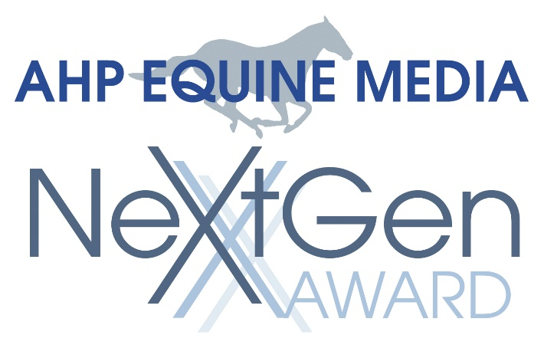
2025 AHP Equine Media NextGen Award
Presented by AHP, an association of equine media, professionals, and businesses.

THE AWARD

The AHP Equine Media NextGen Award is given annually in recognition of an up-and-coming professional who has made a significant impact in advancing equine media while upholding journalistic excellence, integrity, and trust in a competitive communications world.

This distinguished award is a unique opportunity to publicly recognize young equine media professionals whose commitment, dedication, and service have made their careers shine above the rest.

ELIGIBILITY

- AHP membership or affiliation is not required to be nominated.
- Nominees must be between the ages of 25 and 35 by December 31, 2024.
- Nominee’s birth date must be listed on the nomination form.
- Nominees must be a working equine media professional.
- Nominee must be a resident of U.S. or Canada.

There is no nomination fee.

Individuals may be nominated every year until they are 35 years of age by December 31. A new nomination package must be submitted in order for an eligible nominee to be considered in subsequent years. Once a nominee has been chosen as a recipient of an AHP Equine Media NextGen Award, they are ineligible to be nominated for future AHP Equine Media NextGen Awards.

Self-nomination is not permitted. Current AHP staff, contractors, and/or current AHP Board Members are not eligible.

REQUIREMENTS

Nominator must be a current AHP member or employee of a current AHP member in good standing. Nominator must submit a completed nomination form in addition to providing the following required information. Incomplete nominations will not be evaluated.

a) Letter of nomination should substantiate why this individual would be worthy of this award.

b) Documentation to be submitted as verification of contributions include:
- Nominee made contributions that highlight impact, outcomes, and results of the Nominee’s efforts spanning three or more years.
- Nominee’s contributions advanced the equine media industry.
- Nominee demonstrated an understanding of AHP standards of excellence in equine media, including journalistic integrity and ethics.
- Documentation may be submitted in the following formats: jpg, PDF, doc, mp4, and mp3.
- Documentation not to exceed 10 files.

c) Brief overview about the Nominator’s relationship with the Nominee and their length of association with the Nominee. Any direct personal or professional relationship between the Nominator and Nominee must be stated.

SUBMISSION DEADLINE: FEBRUARY 19, 2025

The official nomination form and additional documentation must be received by February 19, Associate Director, at christy.jenkins@easterassociates.com.

SELECTION

AHP Equine Media NextGen Award recipients will be selected by a committee of media professional experts who will review the nominations and evaluate the following:

a) Nominee’s performance demonstrates contributions that are significant in nature and have made a substantial impact within an organization, publication, or on an individual.

b) Contributions cited indicated the Nominee advanced the equine media industry in some way.

c) Nominee demonstrated an understanding of AHP standards of excellence in equine media, including journalistic integrity and ethics.

d) In the case of nomination for a single achievement, nominees should have devoted themselves to a given task whose magnitude, significance and repercussions warrant a level of recognition beyond the purpose served. The achievement in question should be complete or measurable to the degree that the judges can come to an accurate assessment of its consequences and degree of success.

The Committee will choose up to two individuals to receive this award annually.
AHP reserves the right not to select any winners for a particular year if the evaluations indicate the nominations do not meet the stated criteria.

The nominations, evaluation process, and scores are proprietary to AHP and will not be disclosed to any Nominators or Nominees.

The Nominator and Nominee will be notified of the status of the nomination at the conclusion of the evaluation process.

Selection and communication of nomination status will take place at a time designated by the AHP Board of Directors.

RECOGNITION

American Horse Publications will present up to two AHP Equine Media NextGen Awards annually. AHP will announce the winner(s) after notifying the recipients. The individual(s) will be recognized on the AHP website and during the Equine Media Conference (in person or virtual). Each winner will receive an award recognizing their achievement and a complimentary Media Professional conference registration to the 2025 AHP Equine Media Conference in Dallas, Texas, May 15-17.

For nomination information and forms or to submit a nomination, contact:
Christy Jenkins, Associate Director
christy.jenkins@easterassociates.com

